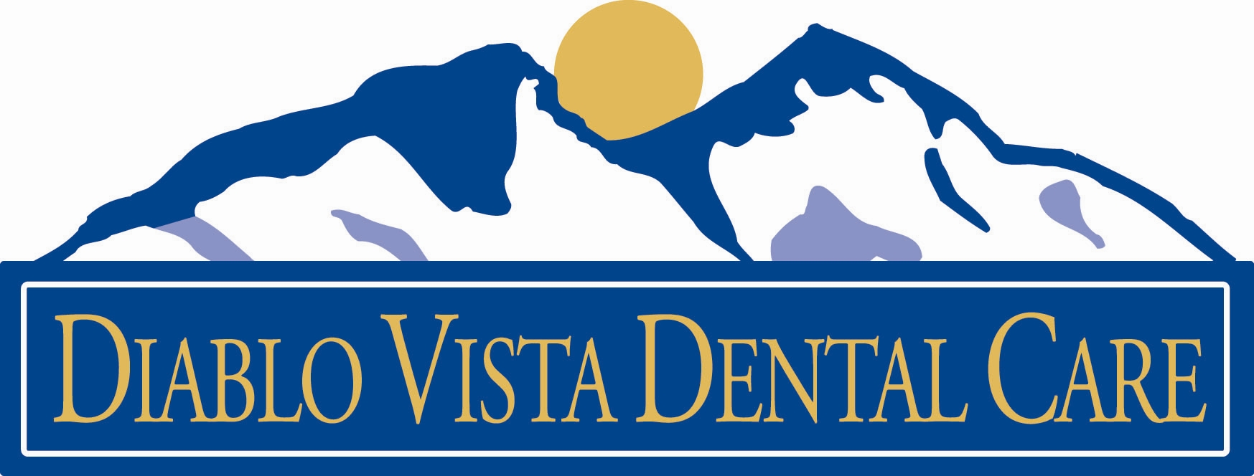

Conscious Sedation Consent Form

The purpose of this document is to provide an opportunity for our patients to understand and give permission for conscious sedation when provided along with dental treatment.

1. I understand that the purpose of conscious sedation is to more comfortably receive necessary care. Conscious sedation is not required to provide the necessary dental care. I understand that conscious sedation has limitations and risks and absolute success cannot be guaranteed. (See #4 options.)
2. I understand that conscious sedation is a drug-induced state of reduced awareness and decreased ability of to respond. Conscious sedation is not to sleep. I will be able to respond during the procedure. My ability to respond normally returns when the effects of the sedative wear off.
3. I understand that my conscious sedation will by achieved be the following route:

Oral Administration: I will take a pill approximately 90 minutes before my appointment. The sedation will last approximately up to 24 hours.

4. I understand that the alternatives to conscious sedation are:

a. No sedation: The necessary procedure is performed under local anesthetic with the patient fully aware.
b. Anxiolysis: Taking a pill to reduce fear and anxiety.
c. Nitrous oxide sedation: Commonly called laughing gas, nitrous oxide provides relaxation but the patient is still generally aware of surrounding activities. Its effects can be reversed in five minutes with oxygen.
d. Intravenous Administration: The doctor could inject the sedative in a tube connected to a vein in my arm.
e. General Anesthetic: Commonly called deep sedation, a patient under general anesthetic has no awareness and must have their breathing temporarily supported. General anesthesia is more appropriate for longer procedures lasting 3 or more hours.

5. I understand that there are risks or limitations to all procedures. For sedation these include:

(Oral Sedation) Inadequate sedation with initial dosage may require the patient to undergo the procedure without full sedation or delay the procedure for another time.

Atypical reaction to sedative drugs which may require emergency medical attention and/or hospitalization such as altered mental states, physical reactions, allergic reactions, and other sicknesses.

Inability to discuss treatment options with the doctor should circumstances require a change in treatment plan.

6. If, during the procedure, a change in treatment required, I authorize the doctor and the operative team have the right to designate the individual who will make such decision.
7. I have had the opportunity to discuss conscious sedation and have my questions answered by qualified personnel including the doctor. I also understand that I must follow all the recommended treatments and instructions of my doctor.
8. I understand that I must notify the doctor if I am pregnant, or if I am lactating. I must notify the doctor if I have sensitivity to any medication, of my present mental and physical condition, if I have recently consumed alcohol, and if I am presently on psychiatric mood altering drugs or other medications.
9. I will not be able to drive or operate machinery while taking oral sedatives for 24 hours after my procedures I understand I will need to have arrangements for someone to drive me to and from my dental appointment while taking oral sedatives.
11.I will need to make arrangements for a responsible adult who is physically capable of handling me, drive me home, remain with me and monitor me for 24 hours.
10.I hereby consent to conscious sedation in conjunction with my dental care.

***For Minors****
The administration and monitoring of general/conscious sedation anesthesia may vary depending on the type of procedure, the type of practitioner, the age and health of the patient, and the setting in which anesthesia is provided. Risks may vary with each specific situation. You are encouraged to explore all the options available for your child's anesthesia for his and her dental treatment, and consult with your dentist or pediatrician as needed.

Please do not bring any personal items such as cell phones, iPods, wallets or purses.
Diablo Vista Dental Care is not responsible for any lost or stolen items.

